“THE VIEW“- June 7th 2017

Fairview Rangers AFC are looking forward to seeing you all at the Fairgreen on Saturday afternoon next to participate in our annual DAMIENS DAY celebration, an event organised to commemorate the life of our dear friend Damien Parker, sadly and tragically lost to us six years now.
The much anticipated annual football game between the Fairview Rangers Legends and The An Post Pirates will kick off at 4.00 pm.
Post match, the fun will thereafter move indoors as the Karaoke Competition is expected to attract vocal talent unrivalled anywhere, Limericks Got Talent goes on display to all and sundry.
A wonderful day always, please come along and join in.
NB: {voice training for novices/beginners at 6.00 pm and live rehearsals with the 16 piece orchestra at 7.00 pm}, an ability to read music is not essential, but if you did sing in a junior infant’s school choir, please bring along your certificates for validation.
Also, if you played any kind of a musical instrument in your years of education, please bring it along, headphones will be provided to the audience free of charge.
************************************************************************************
### We have subsequently learned that our U12 side, defeated in the Volkswagen Junior Masters final on Friday last at the Markets Field, have in fact qualified for the National stages of the competition. Ourselves, winners Aisling Annacotty and third place winners Corbally United have progressed to the later rounds. The eventual outright winner will qualify for a trip to the World Cup in Russia in 2018.
&&&&&&&&&&&&&&&&&&&&&&&&&&&&&&&&&&&&&&&&&&&&&&&
### Our club is anxious to hear from anybody who is interested in volunteering to assist our underage division, particularly the U7 to U11 grades, an aspect of our club activity, where numbers have grown hugely in recent seasons. The club will support your efforts, arranging all relevant coaching and training courses, if you wish to join the fold, please ring Fergal O’Grady at 086 3999005.
@@@@@@@@@@@@@@@@@@@@@@@@@@@@@@@@@@@@@@@@@@@@@
### The best of luck to the four Fairview Rangers players selected on the Limerick Kennedy Cup panel for next week’s competition at UL.
This prestigious U14 event is held at UL every season and kicks off at 4.00 pm next Monday. Our participants are Conor Keane, Riain O’Connell, Josh Twomey and Cillian O’Shea, we wish them well.
^^^^^^^^^^^^^^^^^^^^^^^^^^^^^^^^^^^^^^^^^^^^^^^^^^^^^^^^^^^^^^ ### The Annual over 40’s fund raising football tournament will take place on the weekend of June 17th/18th at Janesboro FC. We have been drawn against Hyde Rangers in round one, the winners will play either Carew Park or Summerville Rovers. If you wish to participate please ring Fergal O’Grady at 086 3999005.

### Next week we will commence an occasional feature on some great servants to Fairview Rangers AFC, our initial choice is the talented and much decorated Seanie Lipper.
ANNUAL SCHOOLBOY/GIRL AWARDS:

### Spread over two evenings last week, we staged our annual schoolboy/girl awards. The well-attended events were a resounding success, and a really enjoyable family occasion. The winners were as follows:
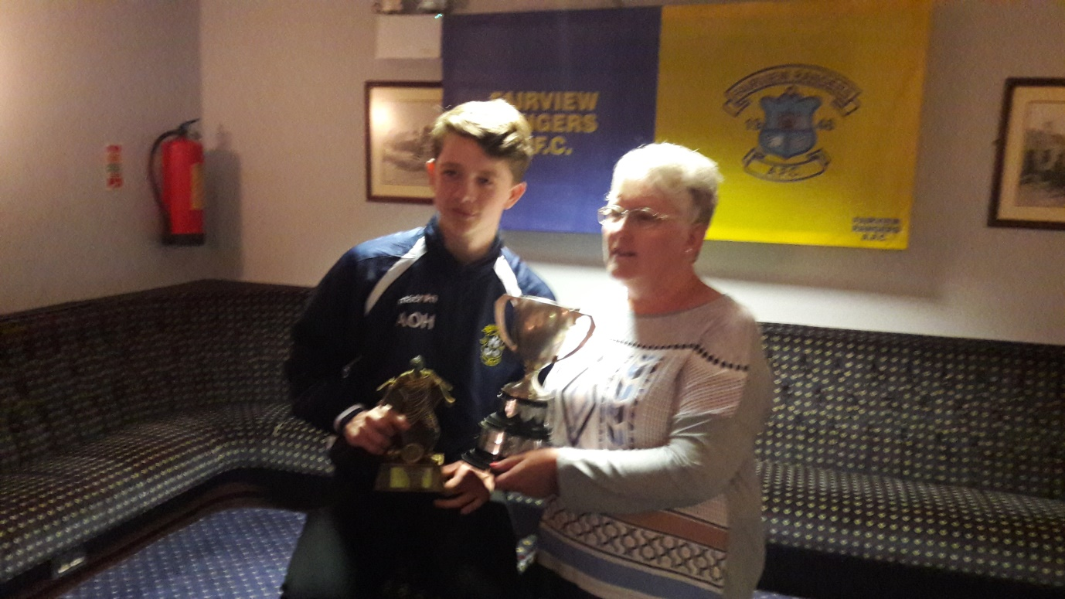
The Christy Carey Memorial Trophy for the clubs outstanding underage player of the season was won by Alex O’Halloran. Alex received his award from Mrs. Geraldine Clohessy, daughter of Christy Carey.
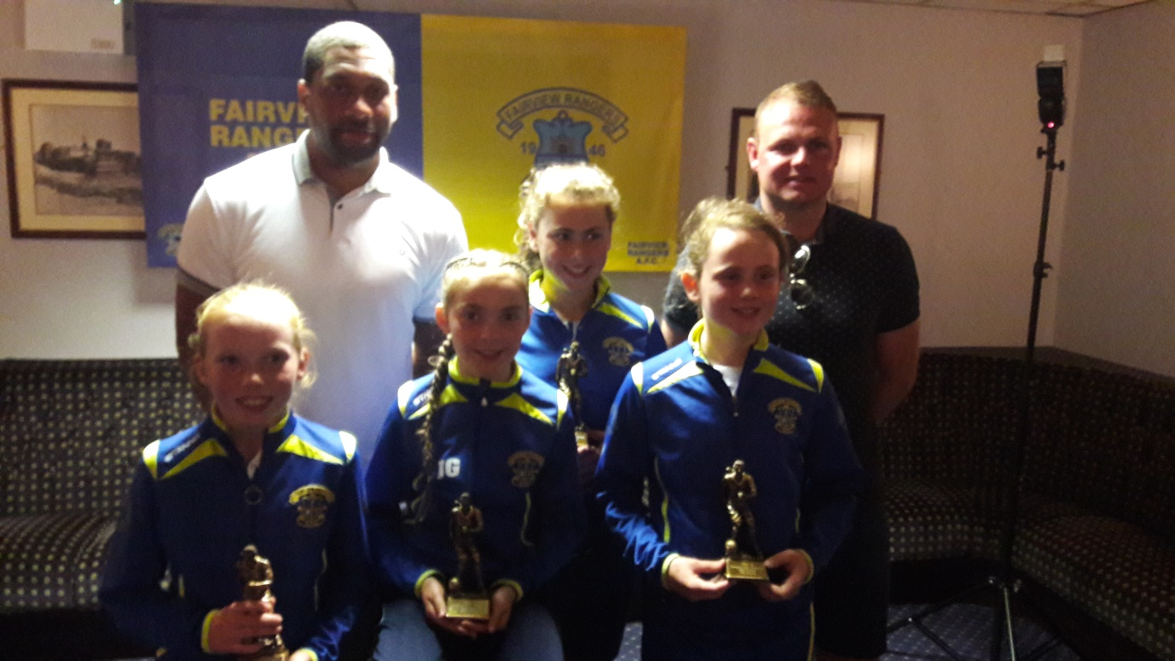
Back Row: L to R: Freddie Hall, Limerick FC,Jenna Slattery who was selected on the Limerick County and District SFAI U14 Emerging Talent Programme and The Limerick U14 Gaynor Cup squad and Robbie Williams Limerick FC
Back Row: L to R: Grace Mc Inerney,Jodie Griffin and Libby Costelloe, all three have been chosen on the Limerick County and District SFAI U12 Emerging Talent Programme
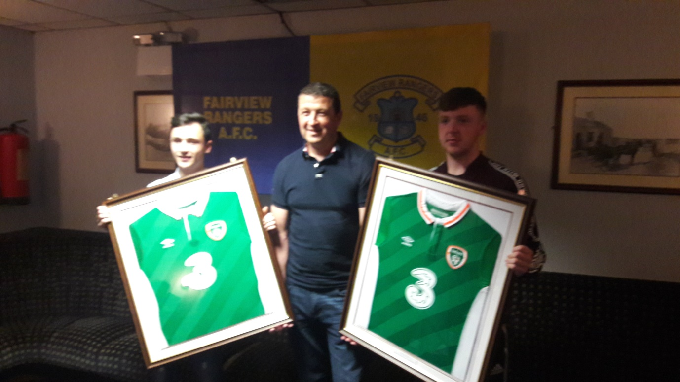
Left to Right: Trevor Daly,club Chairman Derek Whyte and Ryan Mawdsley.Trevor and Ryan display the Ireland U18 jerseys they earned as part of the FAI U18 home based panel for season 2015/16,participating in two games v Wales in Waterford.

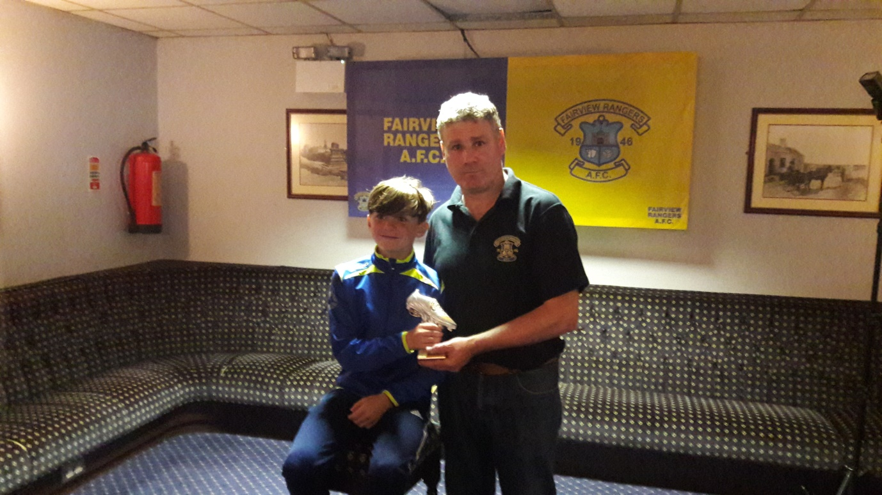
U12 “A” winner Nathan O’Shea pictured with Kevin McCarthy.
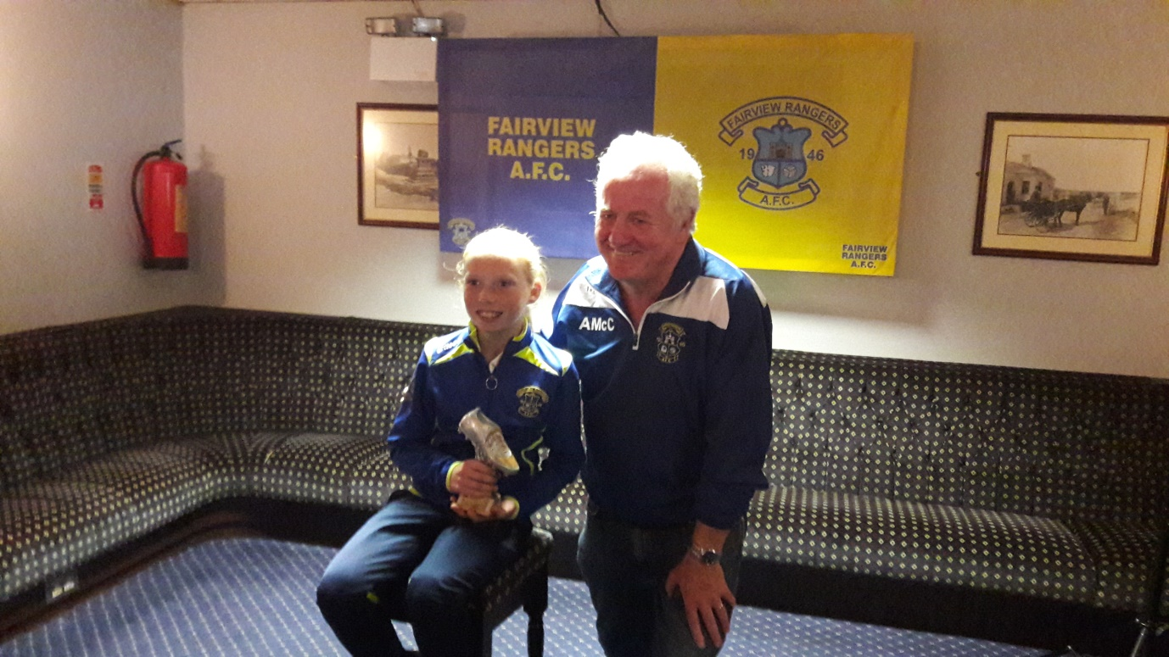
U12 “B” winner Grace Mc Inerney photographed with Andy McCallion.
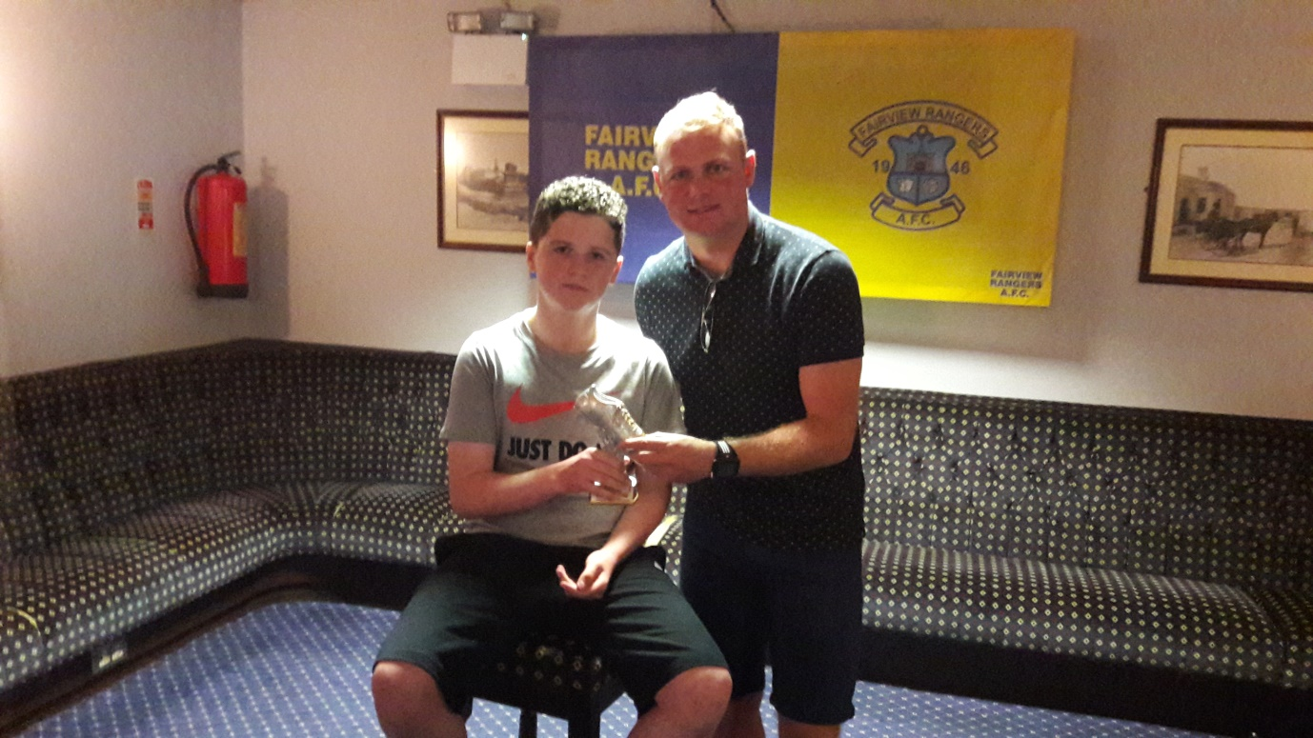
Robbie Williams of Limerick FC presented the U13 “A” award to team captain Anthony Byrnes.
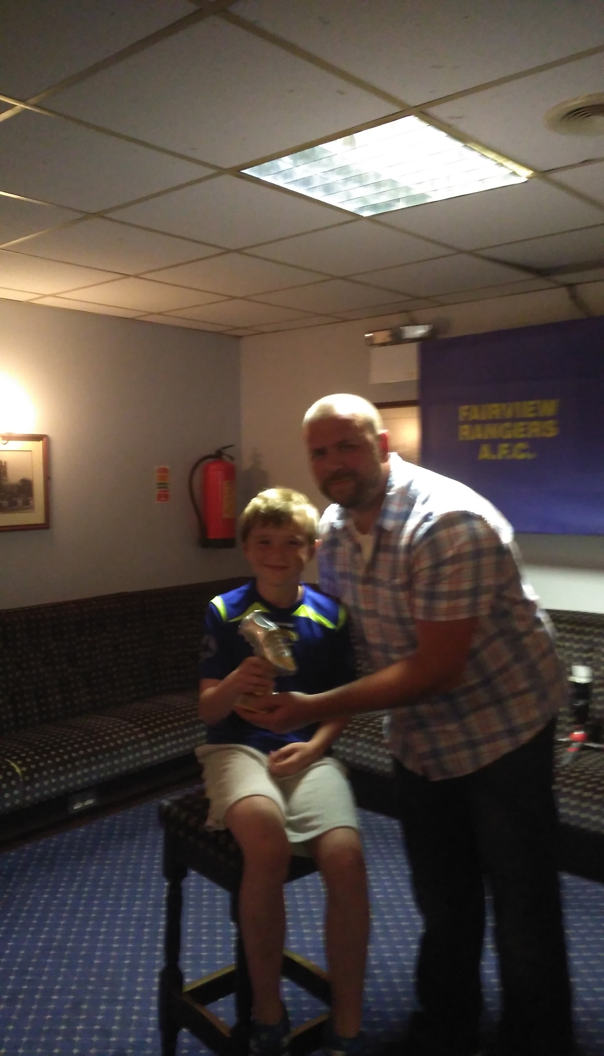
U13 “B” Calum Murphy winner accepts his award from Jeffrey Slattery.

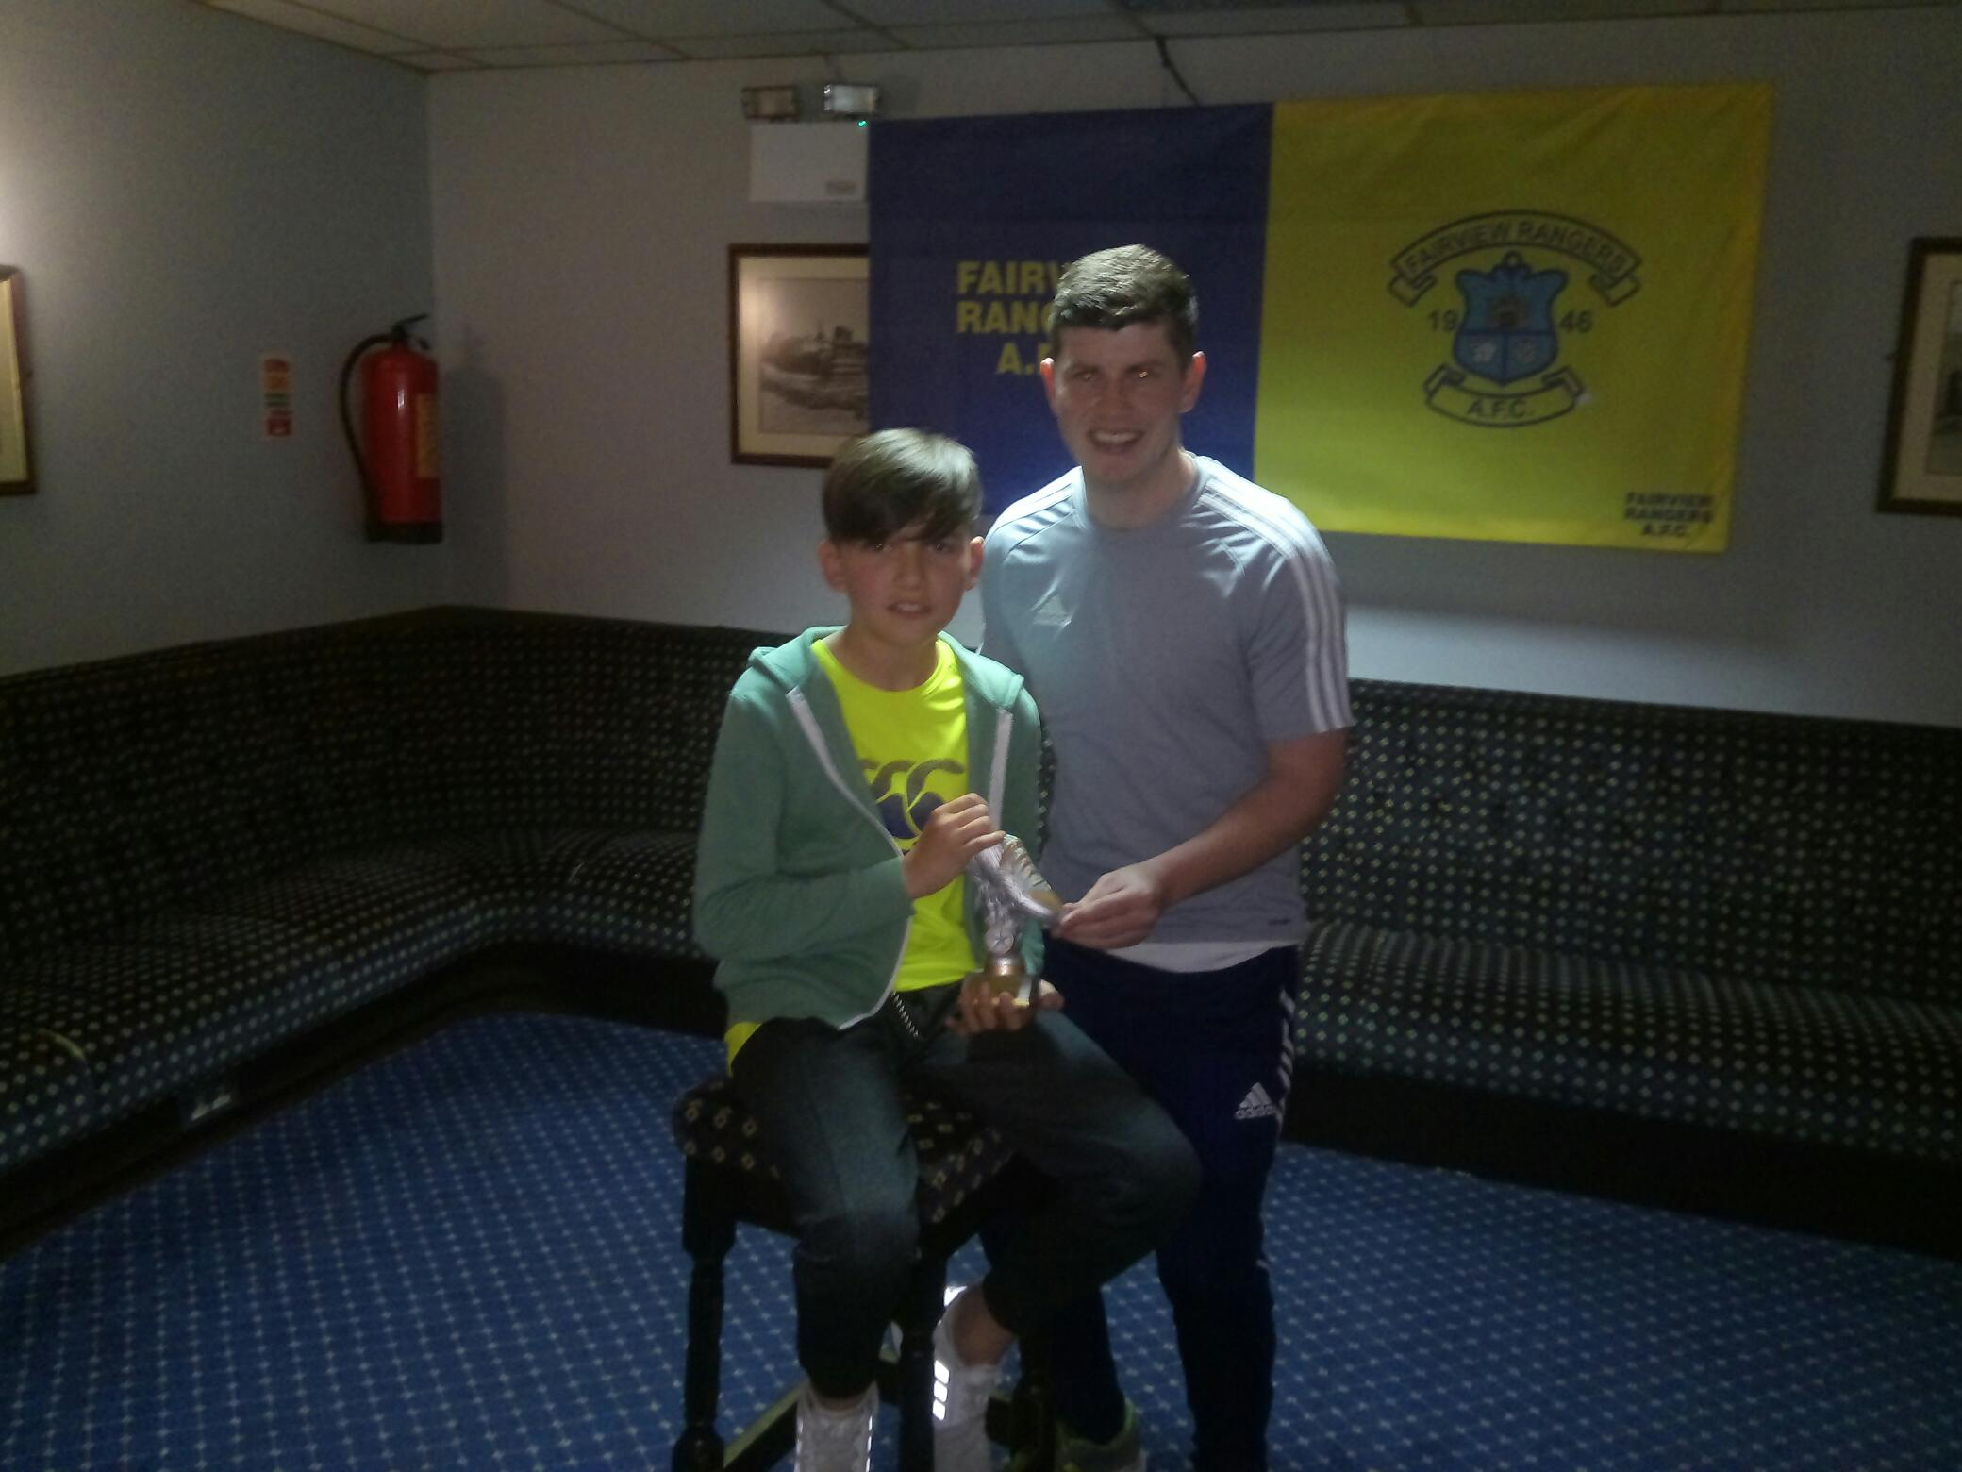
Our 2009/2010 FAI Youths Cup winning captain,Craig Madigan presents the U14 “A” award to his first cousin David Madigan.
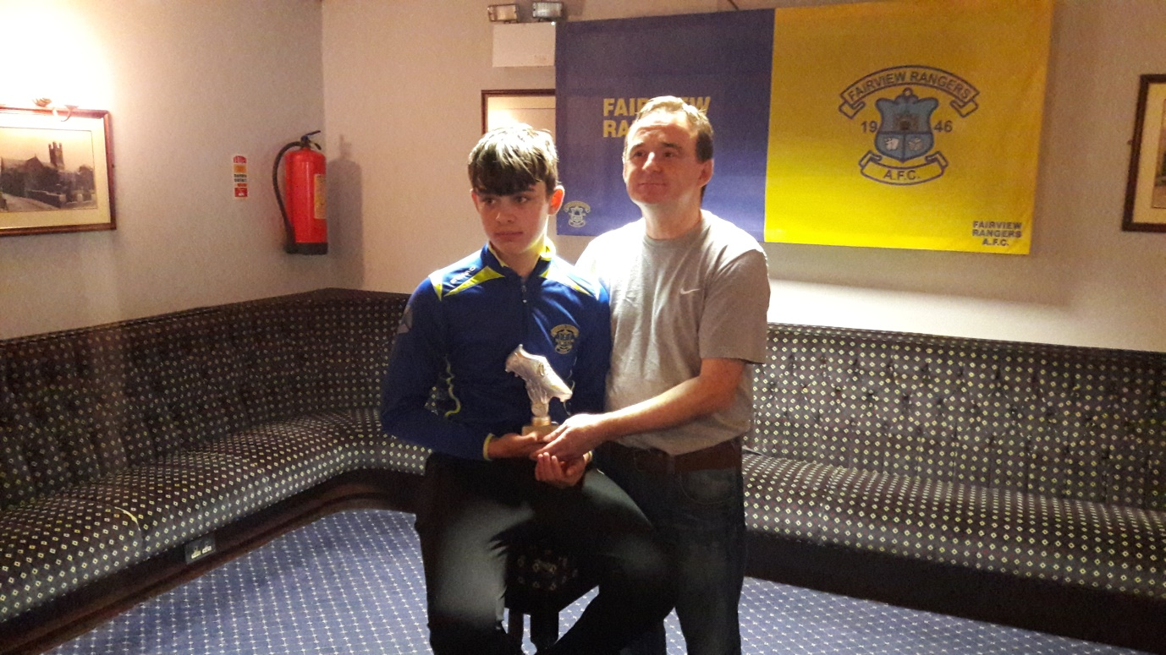
U14 “B” winner Eoin Kelleher receives his presentation from Alan Rice.
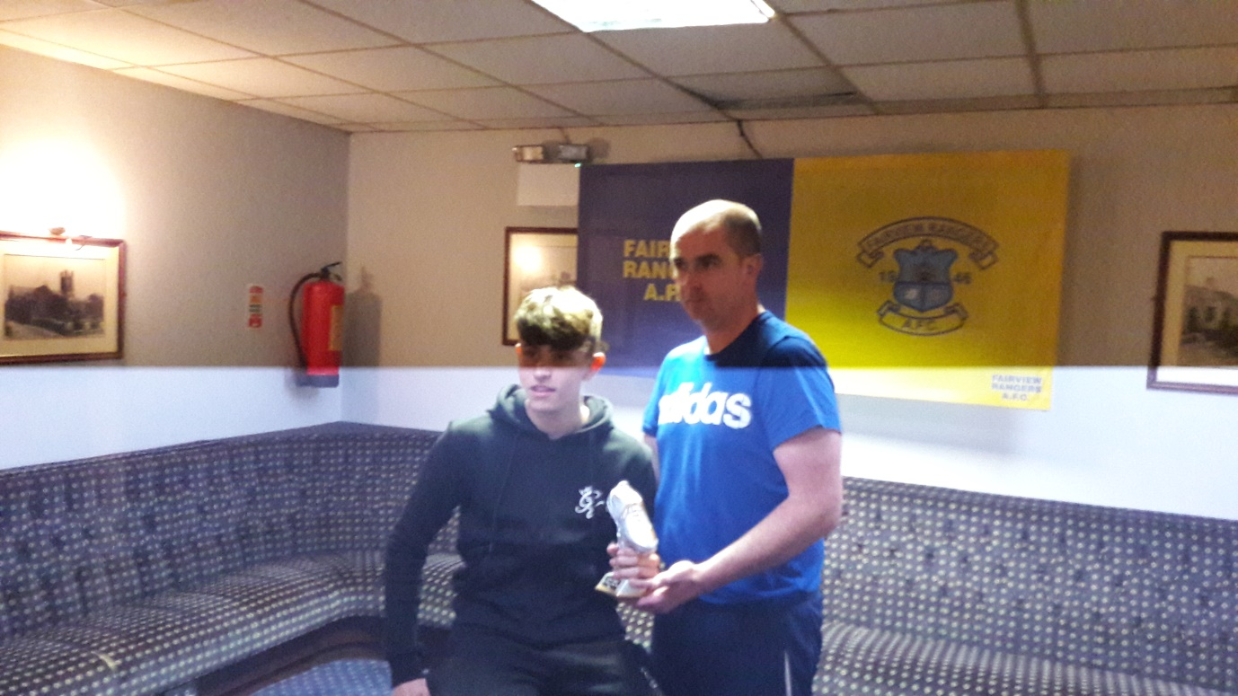
Kevin Kirwan made the U15 ”A” presentation to Zac Sheehan
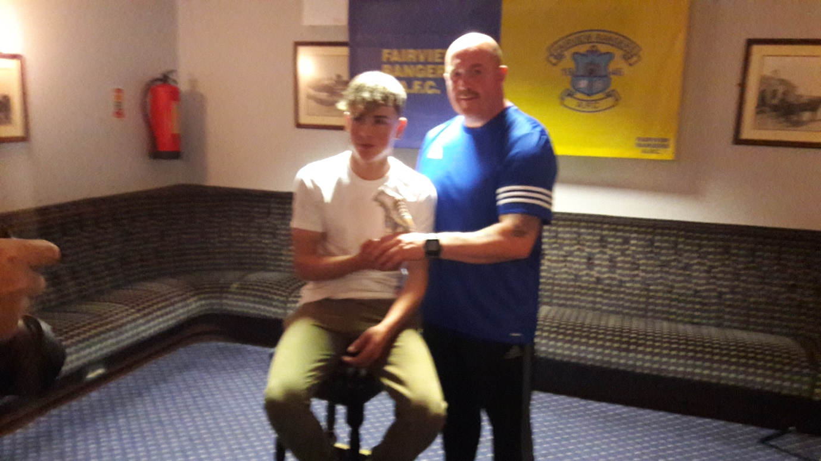
Darran O’Shea with U15 “B” accolade winner Leon Goodwin,Leon scored 33 goals this term,including six in a row in one game.
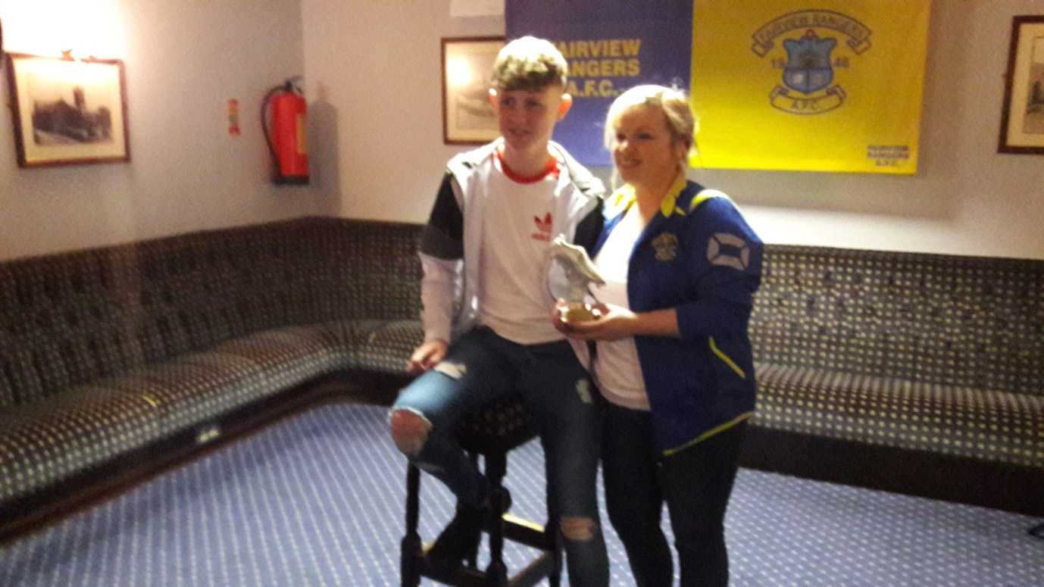
U16 award winner Jack Liddy pictured U16 manager Jennifer O’Brien.

